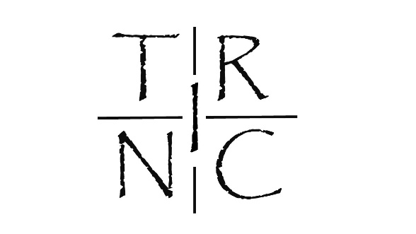
Welcome to the Trinc Clothing’s test pilots application form

I am looking for Product testers. This form is to give me an idea of who you are, what you do and if you would be a good fit for Trinc clothing. Please do not stress if you are unable to complete some sections because if I am honest I am looking for several different things and it may be that I just like you and want to help and you would be a good ambassador for Trinc so have faith. While I cannot guarantee you will be successful just be honest and if you can make me smile that helps.
So complete the form and just email it back to me – Musclesinc@xtra.co.nz
Cheers - John
What types of cycling to you do (please circle or highlight in red)?

Road Mountain Triathlon/multisport Cyclocross

Commuting Other.

If other please explain:

What other sports / activities are you actively engaged in?

Do you compete or participate in any events? If so tell me what you have coming up over the next 12 months.

What are you favorite colours?

So I am trying to avoid stereotypical pinks and purples for the woman’s range. Tell me your thoughts

Is there any colours you will not wear?

What is your favorite piece of kit that you use? For example I have an old Cannondale jacket that the sleeves can zip off and it is so multifunctional that I will make sure there is a similar product in the Trinc range.

Ok so tell me about you and a why you would be a good product tester? Then more information about you and your life the better so have at it.

Please feel free to attach any information that may be relevant. For example if you are a graphic designer I am very keen to chat.

Look forward to hearing from you.

Hugs

John

